* **Activity 1:**

Using Single Row Subquery

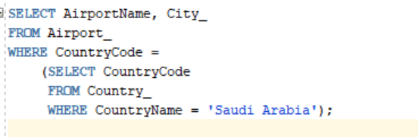

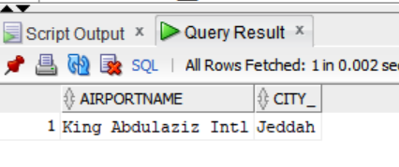OUTPUT: